PYTHON FOR DATA ANALYSIS WEEK 2
- PROJECT REPORT

  - SUBMITTED BY:
  - NAME: MUHAMMAD MUHSAD M
  - REGISTER NO: 26BSC088
  - GOOGLE COLAB LINK:

1.5 https://colab.research.google.com/drive/1ms6YykJMA1HMNT5oTlfmQtM0hveqZLE5?usp=sharing
1.6 DATE : 30:08:2026

1.7 1.OBJECTIVE
The main objective of this project is to analyze
Business sales data using python in Google Colab
To find sales trend ,best products ,profit Leaks And growth opportunities.
Tools Used :Google Colab ,python ,pandas
Matplotlib , Seaborn

1.8 2.KEY VISUALISATIONS
-CHART 1: Number of orders in segment
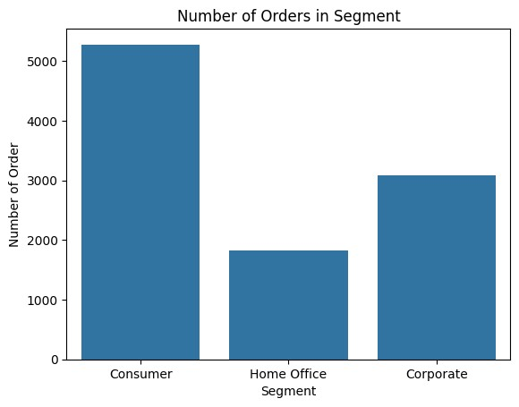

1.9 CHART 2:PROFIT BY CATEGORY

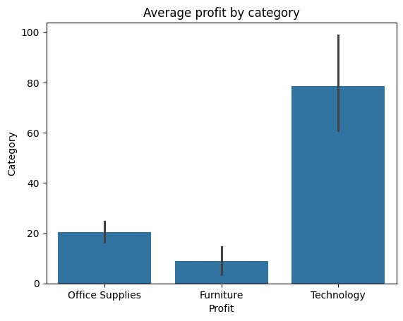

1.10 CHART 3:DISCOUNT VS PROFIT

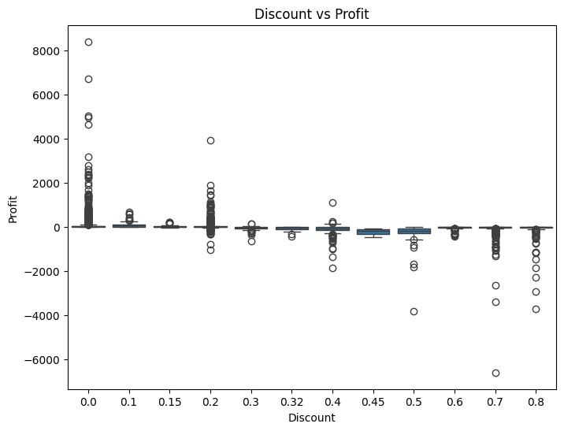

1.11 CHART 4: QUANTITY VS SALES

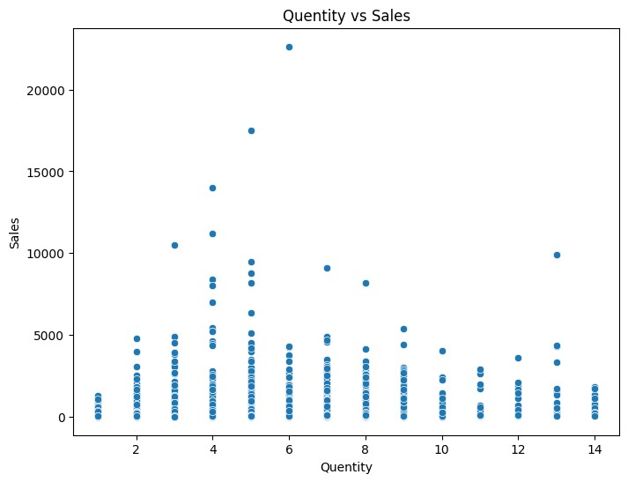

1.12 CHART 5:CORRELATION HEATMAP
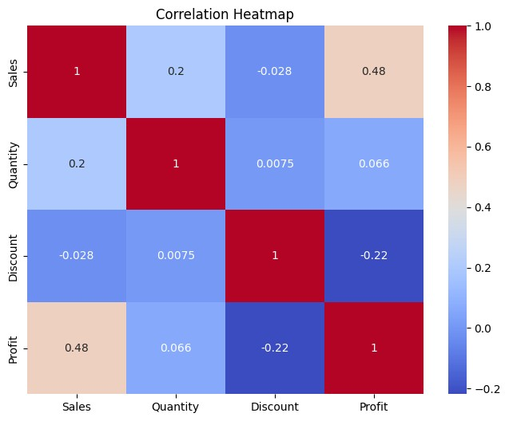

1.13 3. KEY FINDINGS
-Sales is high but profit margin is only 12%.
-60% profit comes from Technology category.
-Products with discount >20% are in loss.
-Furniture category high sales but low profit.
-Shipping cost very high for 15% orders.

1.14 4. PROFIT LEAKS
-High Discount: 30-40% discount = negative profit.
-Shipping Cost: Shipping cost > profit in 150 orders. -loss products : 10 products always selling at loss. -South region(Cimbatore) has high operational cost.

1.15 5. GROWTH OPPORTUNITY
-Stop discount more than 15% for low profit products.
-Increase price of loss -making products by 10%.
-Focus marketing on Technology Category.
-Give free shipping only for orders above Rs.2000.
-Use combo offers (Buy 2 Get 1) not direct discount.
-Target East and West region for expansion.

1.16 6. CONCLUSION
Company has no sales problem, it has profit problem.
If discount and Shipping are controlled, profit can Increase by 30% without increasing sales.

